**Script Template** - UX Research

# Script **Summary**

Here are a couple of options to attach a **summary** of the main sections of your script at the beginning of the document: either by leveraging the **automatic functionality (V1)** or by **copy-pasting the table below (V2)**

## **Version 1**

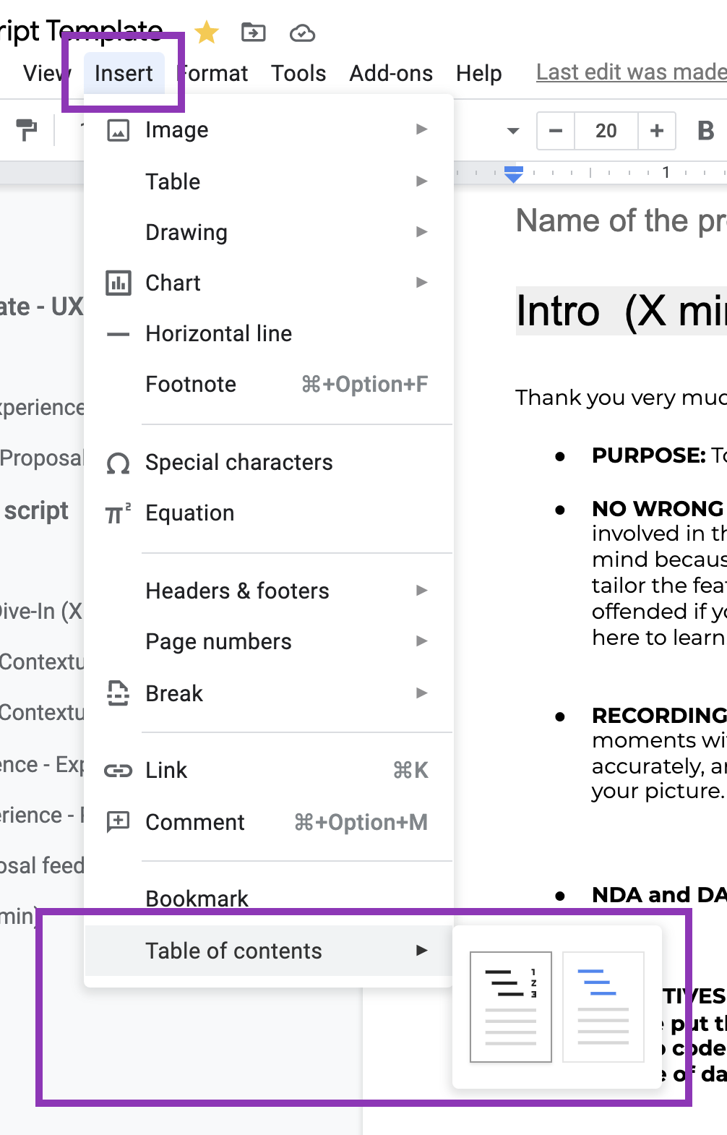

## **Version 2**

| Intro | AIM - XXX | X minutes |
| --- | --- | --- |
| 1. Contextual Questions | AIM - XXX | X minutes |
| 2. Ideal Experience - Expectations | AIM - XXX | X minutes |
| 3. Current Experience - Pain points | AIM - XXX | X minutes |
| 4. Design Proposal feedback | AIM - XXX | X minutes |
| 5. Usability test checklist | AIM - XXX | - |
| Thanks and Closing | AIM - XXX | X minutes |
|  | TOTAL | X minutes |

# User session **script**

Name of the project (Cluster)

Since the research will be conducted in **[Name of the country]**, the following questionnaire will be written in **[Language name]**.

## Language 🇬🇧

## **Intro (X min)**

Thank you very much for your participation in our study.

**PURPOSE:** To improve our application, and understand your need towards Glovo

**NO WRONG ANSWERS**: we are interested in your unique point of you and I am not involved in the design of this app. We encourage you to tell us EXACTLY what’s on your mind because the more honest and opinionated you are, the better our team can tailor the features and designs to the organization and its customers. We will not be offended if you tell us that certain things don’t make sense in your opinion. We came here to learn.

**RECORDING -** We would like to record our discussion today, and will capture certain moments with screenshots. This is merely to ensure that we capture your opinion accurately, and I can assure you that your name will not be used in association with your picture.

**NDA and DATA CONSENT -** check if they signed it

**INCENTIVES -** We will be sending you an email with a form you would need to fill. Please put the email address you used to sign in in Glovo as we will transfer the Promo code to your account. You should be receiving the promo code in the next couple of days.

**ZOOM ON PHONE** - Before we start, do you both have zoom installed on your laptop and phone?

**QUESTIONS -** Before we begin do you have any questions or concerns? OK, let’s start.

***MODERATOR: Remember to hit screen share and hit record on Zoom at the start of the session.*** *Questions marked with* ***\**** *indicate priority questions. Questions without* ***\**** *can be skipped in case of lack of time.*

## **Contextual Dive-In (X min)**

### **Version 1**

**Personal background**

* What is your name?
* What do you do?

**Ordering online habits**

* How often do you order food online?
* Describe to me your habit : when/ how do you prepare when placing a food order?
* When/what was your last order?

**Competitors**

* What food app/website do you use? Do you use multiple ones? why?
* Did you always use the same sites/app? (probe history)
* When ordering food online, what do you consider? why?

**Challenges**

* When thinking about browsing for food on an app what are your main issues? *(navigation, finding restaurant, comparing pricing and options, address location, delivery times etc)*
* What do you use the most? why?

### **Version 2**

* What do you do?
* Do you usually eat out?
* What food delivery apps do you generally use? Why?
* Tell me how you met Glovo and what you use it for. How long have you been using Glovo?
* When was your last order? What was it?
* Tell me a bit about how you usually order food... Is it at night, on weekends...

Do you have a habit of ordering food from home? How often do you order? What do you look for?

* Why did you decide to buy online/specific food? Would you like to share your motivations for ordering food?
* Have you had any experience where you finally did not place a food order online? Why?
* Do you order food by yourself or in a group?

-> Great, now let's move on to the next phase.

## **Ideal Experience - Expectations (X minutes)**

***{Find out the customer shares a mental model with help of Miro - the step-by-step he/she goes through}***

**Moderator to pick the right journey/user path accordingly on** MIRO.

I would like you to take me through your first experience with glovo from start to finish. Please bear in mind that the questions I will ask are related to the difficulty you might have had with the functionality of the app.

We would like now to understand the difficulties you might have had navigating the website/App. For this we encourage you to share your screen and go on the Glovo website, and show us where you had difficulties.

* Tell me how your ideal X experience looks like?
* How do you usually X?
* How would you expect to find X?
* What is more important for you when X? Why?
* How would you like to X?
* What are the triggers/drivers that would make you X? Why?

**For all task ask - Overall usability**

* What do you think about the way the elements are organised? **Why?**
* Did you understand what is shown? **Why?**
* What do you think/feel about this? **Why?** What do you think about the way information about each product is displayed? **Why?**
* What do you like / dislike? **Why?**
* What do you understand / don't you understand? **Why?**
* Can you tell me about <interaction element>- What worked what didn’t? Why?
* What do you miss / add? **Why?**

## **Current experience - Pain points (X min)**

***{Customer shares screen & opens up Glovo App}*** *I’m going to ask you to share your screen through your phone and open up Glovo app. Next, I would like you to XXX*

***{Observe where the customers goes, clicks, how he/her discovers}***

*Imagine now XXX and that you want to XXX. I’m going to ask you to XXX:*

*Wait until the task is finished.*

***{Pain points & expectations of food orders}***

* What do you think about the way XXX is shown? **Why?**
* Do you understand what is shown? **Why?**
* Tell me what you find most difficult when XXX. **Why?**
* How would you describe your experience with XXX? **Why?**
* What is most important when XXX? **Why?**
* What do you think about XXX? **Why?**
* *XXX screen:* What are you doing here? What do you think/feel about this? **Why?**
* What do you think about XXX are displayed? **Why?**
* What do you think about the way information about XXXis displayed? **Why?**
* What do you like / dislike? **Why?**
* What do you understand / don't you understand? **Why?**
* What do you miss / add? **Why?**

## **Design proposal feedback (X minutes)**

*I would like to present you XXX and i’ll like to get your feedback -* ***Share prototype link with user and ask them to share the screen***

* How do you feel about this prototype? **Why?**
* What are your first impressions?
* Do you prefer it to the XXX displayed in the app? **Why?**
* What do you like / dislike? **Why?**
* What do you understand / don't you understand? **Why?**
* What do you miss / add? **Why?**
* What do you think about X?
* How do you feel about X?
* Based on the homepage, what do you think X offers?
* What part/section are you drawn to first and why?
* How do you feel about this experience?
* Do you like it/not like it? Why?
* Do you miss/would like to add something?
* How could it be improved?

## **Usability test checklist**

Let’s start with the first task. I’d like you to do X and guide me through each step of the way by thinking out loud with me. At every step, please tell me what you see, think, and feel. Please wait for my signal before clicking forward.

*[For every screen, keep in mind the following checklist of items:*

**Communication**

* *Visuals/icons (clear/unclear, first reactions/interpretations, colours)*
* *Copy (clear/unclear, first reactions/interpretations, tone of voice)*
* *Perception (positive/negative, associated emotions)*

**Interaction**

* *Buttons (mental model, intuitive/not intuitive)*
* *Links (mental model, intuitive/not intuitive)*
* *Scroll/Swipe (mental model, intuitive/not intuitive)*
* *Components (mental model, intuitive/not intuitive)*

**Navigation**

* *Entry point*
* *Errors (severity, recovery degree)*
* *Confidence (doubts, intuitive/not intuitive)*
* *Flow (sequence, length perception: too many/too few steps)*

## **Goodbye (X min)**

* We thank you for your participation in our study. Your feedback has been very useful and will help us to improve greatly.
* Would you like to share anything else?
* Incentive process - how do we do it

# Script **example**

Check out the [**Homepage Redesign project script (CX)**](https://docs.google.com/document/d/15EV77ExNzzQevTzSj5vOud2MilPMZu859oFZFZ1_Bls/edit?usp=sharing) as an example